ALLEN ORTHOTICS AND PROSTHETICS

2502 West Ohio Avenue 1921 East 37th Street, Suite A Midland, Texas Odessa, Texas
432-683-3788 432-332-9821

CROW Boot Use and Care Instructions

Function:
The purpose of your Charcot Restraint Orthotic Walker (CROW) boot is to immobilize and accommodate the shape of your foot/ankle in order to help prevent the condition from worsening.

Use:

Donning Your CROW Boot

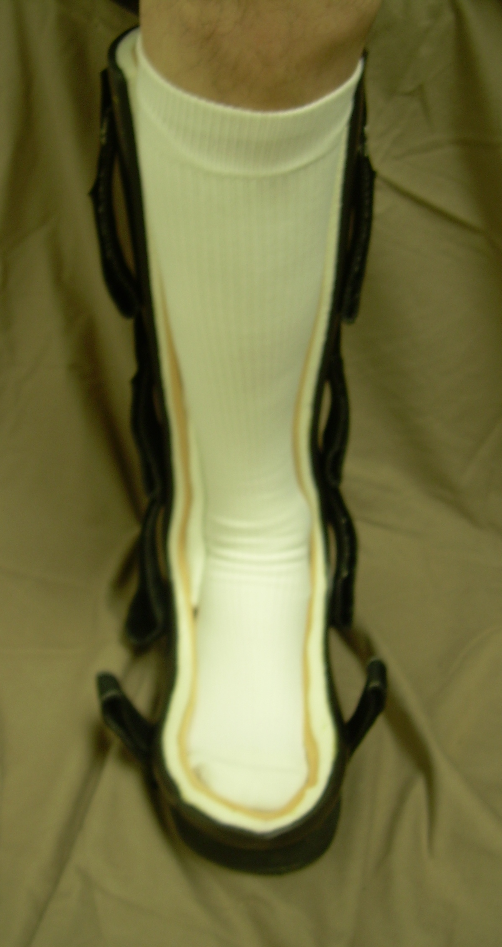
Before donning your orthosis always check for any foreign objects that may have fallen in while you were not wearing the boot.

- Always wear a sock that is at least as tall as the orthosis. This will protect your skin from friction.
- Don the posterior section first by placing your foot in the foot bed and sliding your heel and calf into place.
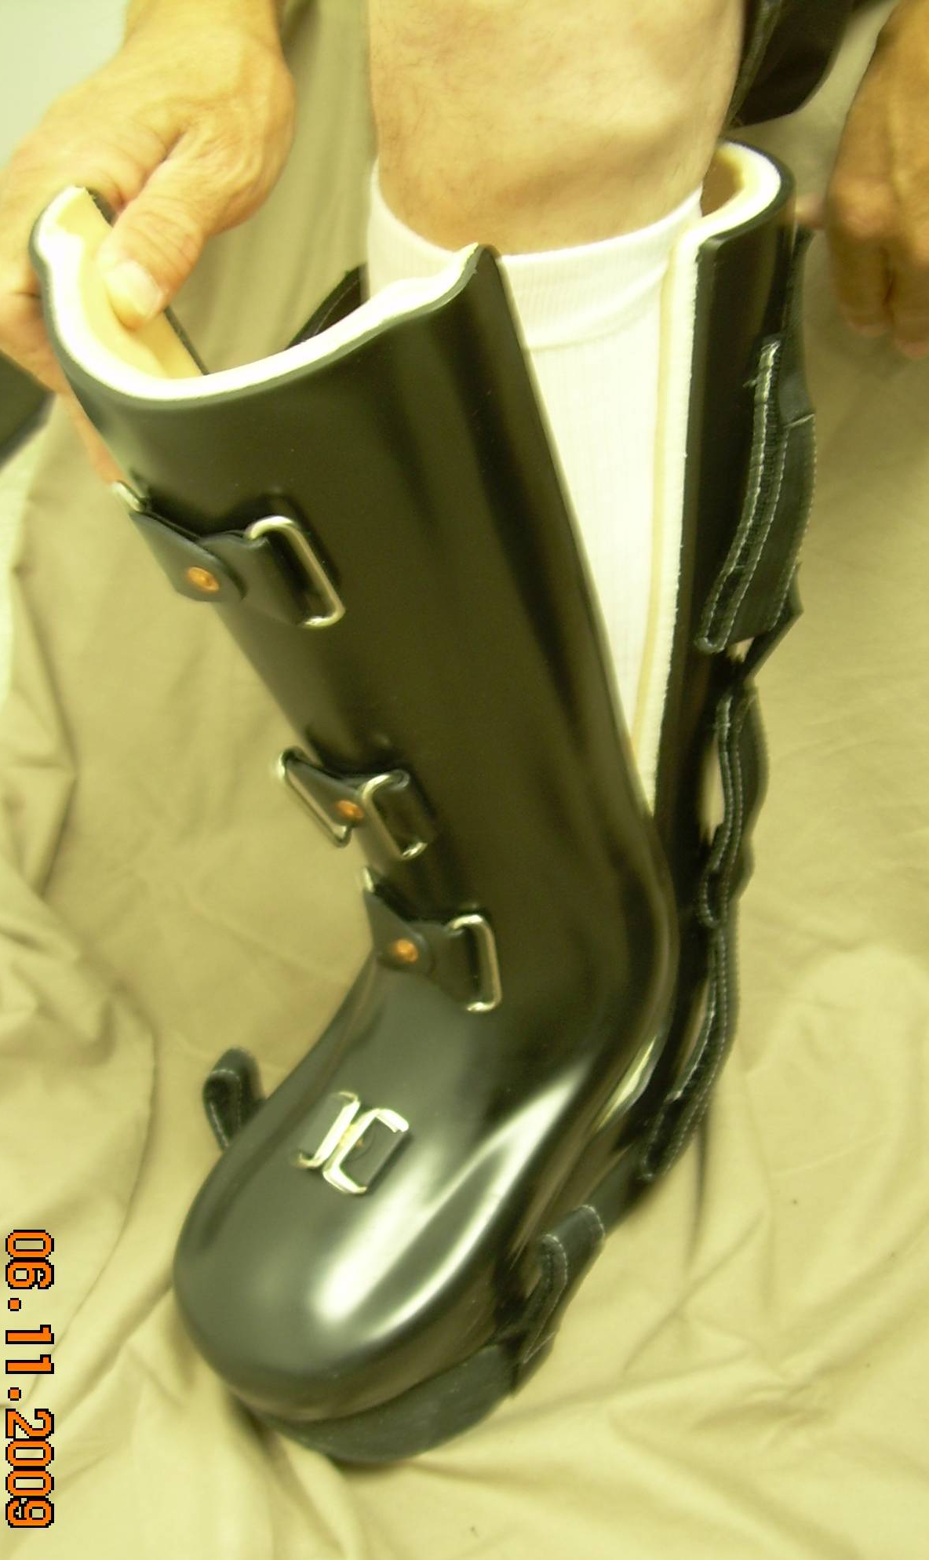
- Check for any edges of foam that may have turned inward during the donning process. If any is, found run your finger along the inside edge to return it to its proper position.
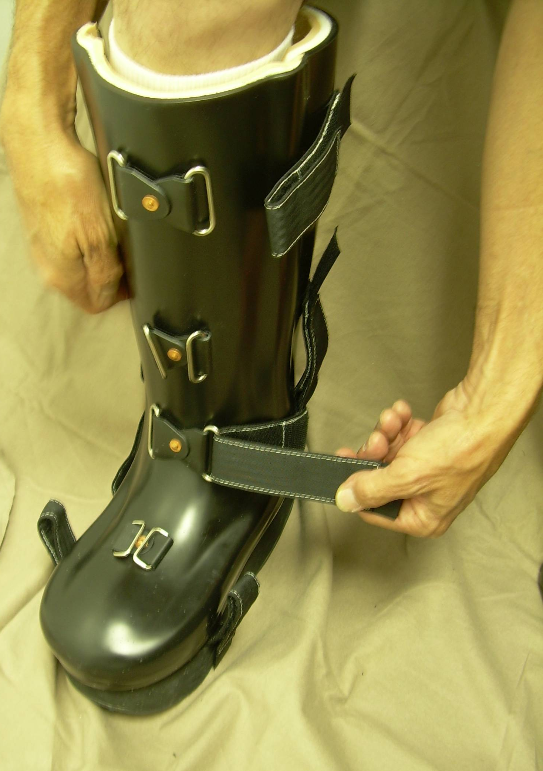
- Now, don the anterior section. For this process you may find that it is easier to position the foot section first then the upper portion. The edges should overlap and touch if the anterior section is in the proper position.
- Strap the anterior section to the posterior section starting with the instep straps. Velcro the straps simultaneously to ensure that the same amount of tension is maintained on both sides.
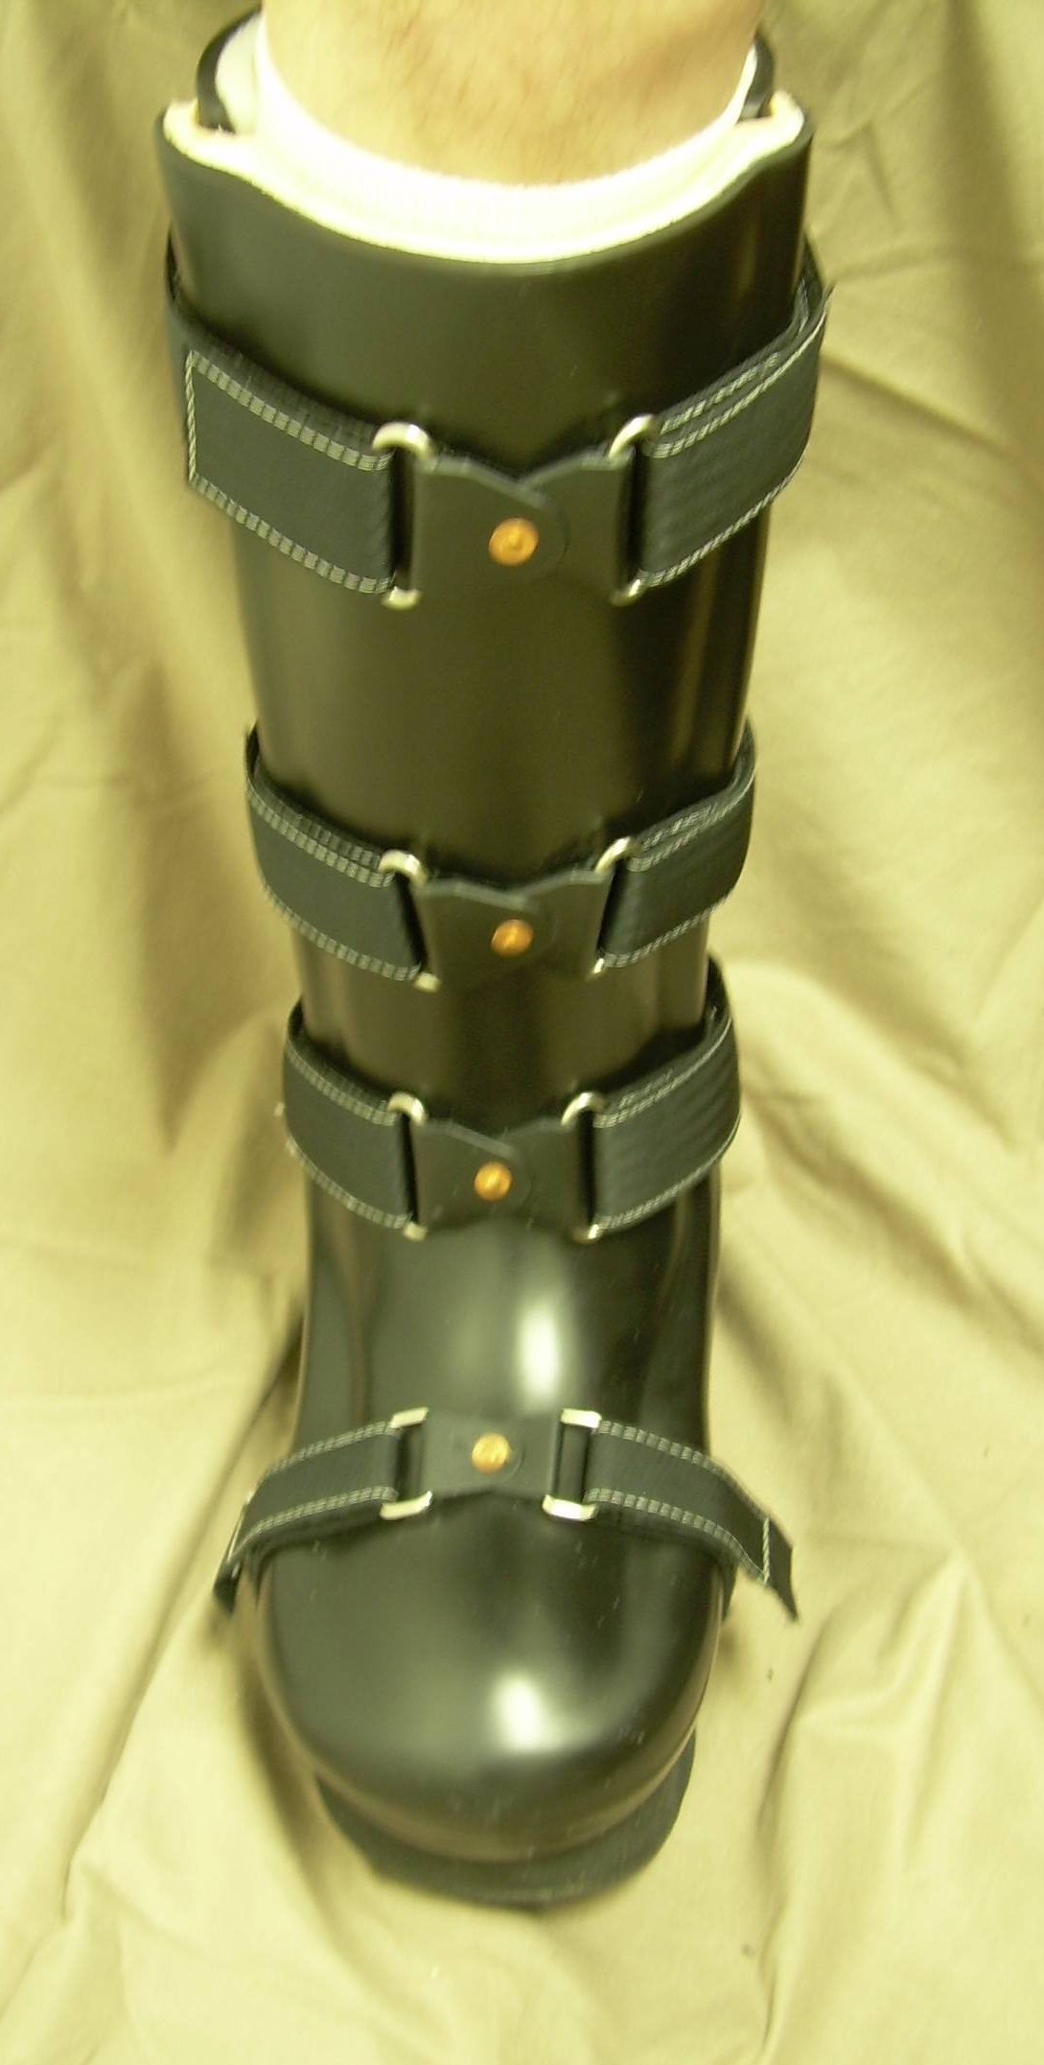
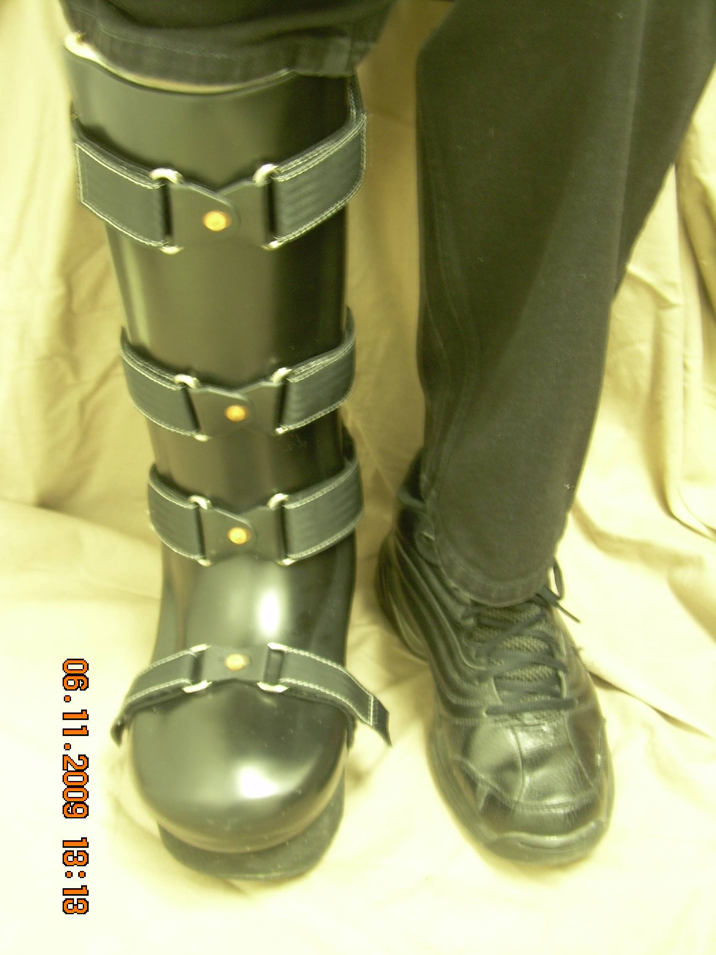
- The sole is designed with a rocker bottom to make it easier for you to walk in, since your ankle is immobilized in the boot. The rocker bottom also helps to reduce friction caused by ground reaction forces.

Wear Schedule

You should wear the orthosis according to the wear schedule your prescribing physician gave you. If none was discussed, contact the physician’s office for advice.

Wear Schedule:
Follow the wear schedule provided by your prescribing physician. If one was not discussed, call the physician’s office for a recommendation.

Care/Maintenance

The lining of your CROW Boot should be cleansed everyday. Wipe both the posterior and anterior sections down with rubbing alcohol on a cloth. The outside of the boot may be washed with water.

Precautions:

Always remember that before you apply your orthosis, you should check for any foreign objects that may have fallen in while you were not wearing the boot. After you have worn the orthosis, check your skin for redness over boney areas. Areas of redness should go away within 20-30 minutes. If the red areas do not subside or you experience pain, contact the office at one of the numbers listed above and schedule and appointment for an adjustment to be made. Avoid using lotions on your skin as this will soften the tissue. Soft skin is more susceptible to skin break down. Always wear a sock that is at least as tall as the orthosis. This will protect your skin from friction. When walking, maintain short strides to prevent rapid rolling of the orthosis that could cause imbalance. Caution should be taken when walking over barriers due to the bulk. To prevent tripping, make sure that your CROW boot clears the floor as you swing your leg through during walking.

Report failures, malfunctions or changes in your physical condition to us as soon as possible.

